1. Write program to perform AES subbyte and inverse subbyte transformation.
Hints: 128 bit input to 4, 32 bit words. Then
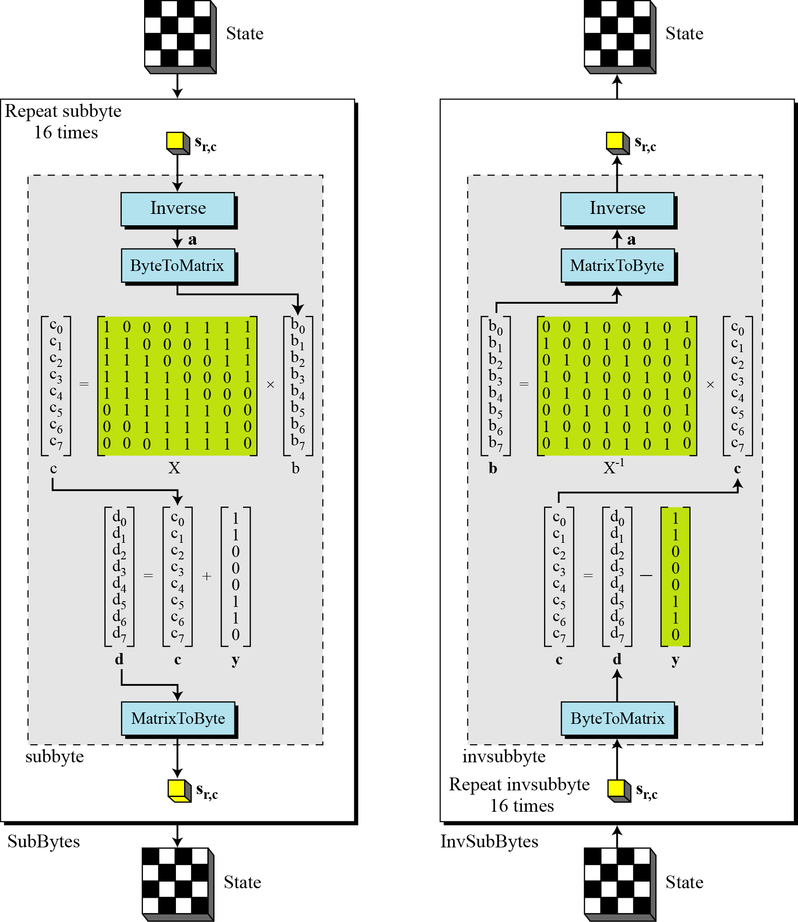

2. Write a program to generate keys of different rounds of AES.

Hints:

K0 |  |  |  |  | 24 | 34 | 31 | 13
K1 |  |  |  |  | 75 | 75 | E2 | AA
K2 |  |  |  |  | A2 | 56 | 12 | 54
K3 |  |  |  |  | B3 | 88 | 00 | 87

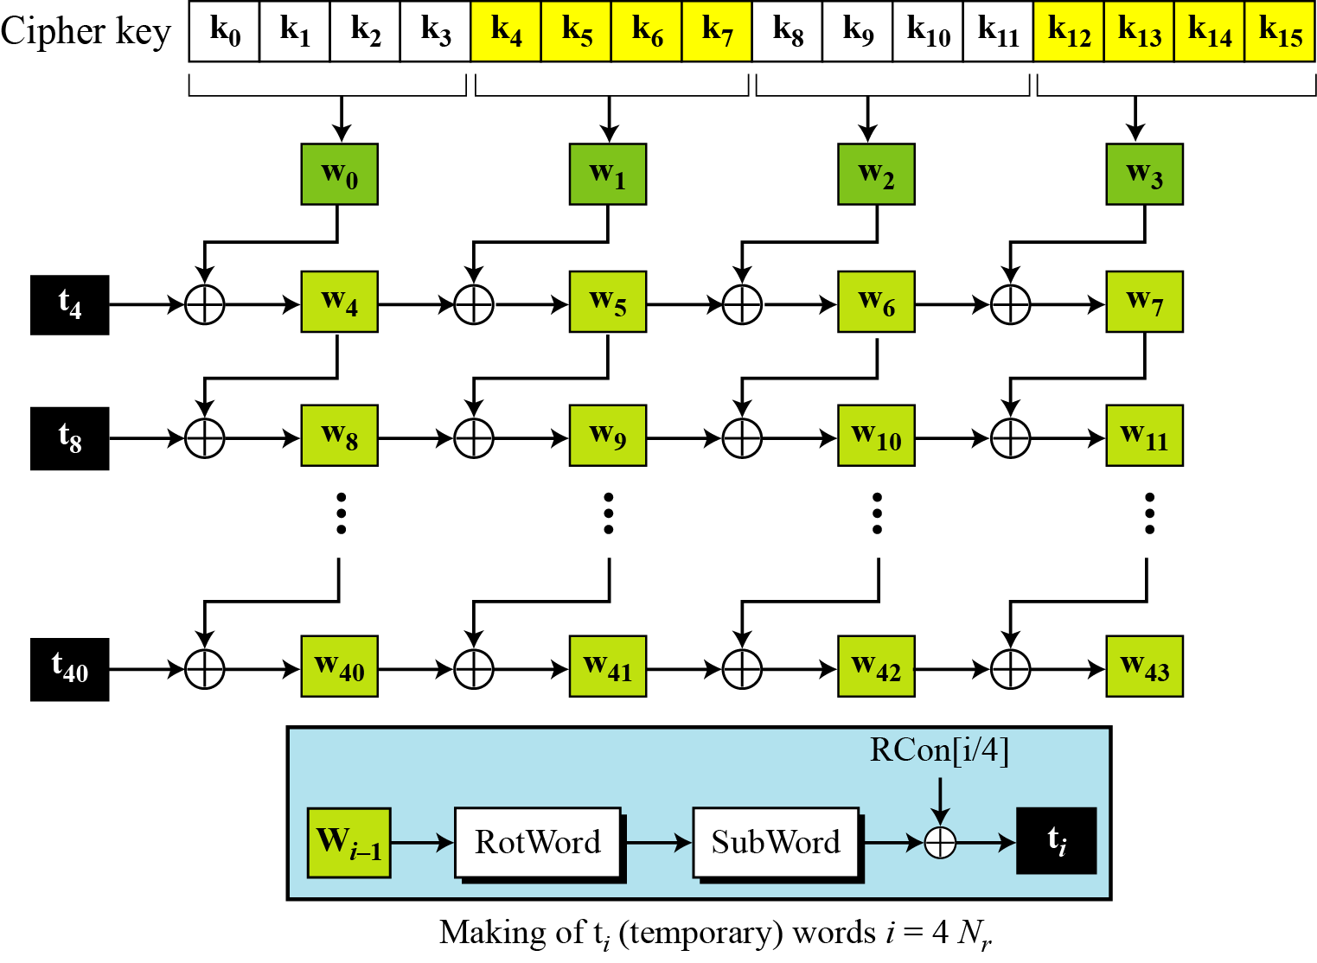

Function g
g takes w₃ as input and perform one byte left shift to form a RotWord.
SubWord performs a byte substitution on each byte of its input word, using the AES S-Box
W3 | RotWord | SubWord | XOR with Round constant
13 | AA | AC | AD
AA | 54 | 20 | 20
54 | 87 | 17 | 17
87 | 13 | 7D | 7D

Round Constants
R1 | R2 | R3 | R4 | R5 | R6 | R7 | R8 | R9 | R10
01 | 02 | 04 | 08 | 10 | 20 | 40 | 80 | 1B | 36
00 | 00 | 00 | 00 | 00 | 00 | 00 | 00 | 00 | 00
00 | 00 | 00 | 00 | 00 | 00 | 00 | 00 | 00 | 00
00 | 00 | 00 | 00 | 00 | 00 | 00 | 00 | 00 | 00

- Pre-round key (w₀, w₁, w₂, w₃) is generated from the cipher key
  - w₀ = [k₀,…, k₃], w₁, w₂, w₃…
- For i= 4 to 43
  - If i ≠ 4r, w_{i}= w_{i-1}⊕ w_{i} (r is some integer)
  - Else w_{i}= t ⊕ w_{i-4}, where
t= SubWord(RotWord(w_{i-1}))⊕ RCon_{int(i/4)}
(RCons is given in Table)

